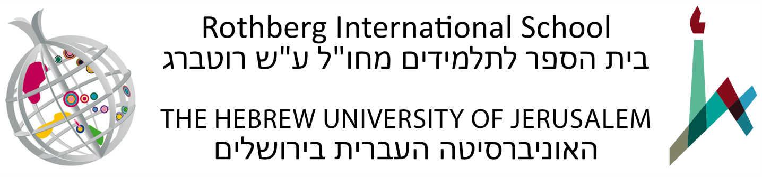

Colloquial Arabic for Beginners: Immersive Program (48913)
Summer Semester: June 17 – July 18, 2024
Various days and times per week, Sunday through Thursday
100 Academic Hours, 7 Academic Credits
Office hours: Teachers will hold office hours to assist students.
Tentative Syllabus

Course Description
This program is crafted to immerse students in spoken Arabic, emphasizing the Urban Palestinian dialect of Jerusalem, a key Levantine dialect. Students will be introduced to the rich tapestry of Arabic culture, traditions, and daily life, all while honing their conversational skills.
The classes and activities aim to equip students with a basic proficiency in spoken Arabic, focusing on the phonology, morphology, syntax, and semantics of the language. Additionally, students will gain insights into Arabic culture, literature, and the appropriate cultural responses in day-to-day Arab interactions.
The principle of immersion underpins the program, emphasizing a holistic understanding of Arabic by actively using the language both inside and outside the classroom. Engagements with local native speakers during field trips and activities further enhance the immersion experience.

Course Objectives
- Master the nuances of pronunciation in spoken Arabic.
- Develop conversational skills in Arabic, focusing on familiar topics.
- Understand the phonology, morphology, syntax, and semantics of spoken Arabic.
- Gain insights into the cultural, traditional, and daily aspects of Arab life.
- Respond appropriately in culturally significant situations within Arab society.
Course Requirements
• Students must attend all classes, field trips, and activities.
• All assignments and exams must be completed.
• Assignments, papers, and exams are individual tasks, unless otherwise stated.
• Adherence to the Hebrew University and Rothberg International School policies is mandatory.

Class Attendance and Participation
Students are required to participate in all components of the program and to attend all classes and activities. Failure to attend classes will result in a student being denied the right to partake of the final assignment and receive a final grade in a course. Students who have a justified reason to miss class (illness, mourning, etc.) must communicate with their instructors and the Department of Summer Courses and Special Programs, and complete the material that they have missed. Students who have missed class due to illness must obtain a signed and stamped sick note from a treating physician and submit it to the Department of Summer Courses and Special Programs immediately following their return to class. Failure to do so will result in an unexcused absence. The Department reserves the right to refer the issue to an Academic Committee. In some cases, the Academic Committee may decide, in light of the requirements of the course, that it is not possible to make up the missing course work.
Final Grade Breakdown
- Active class participation, timely assignment submissions, weekly quizzes, and midterm exam - 40%
- Final exam - 60%
Course Outline
Core Course in Spoken Arabic
Classroom Instruction and Co-curricular Activities
• The class convenes for multiple sessions each week, focusing predominantly on spoken Arabic (including active usage, listening comprehension, grammar, syntax, etc.)
• The sessions also include immersive trips and cultural activities to Arabic-speaking areas.
Course Materials
The program will generally align with the outline and structure as presented in the following readings (Must be purchased before arrival):
- Kristen Brustad, Mahmoud Al-Batal, and Abbas Al-Tonsi, Alif Baa: Introduction to Arabic Letters and Sounds, 3rd ed. (Washington, D.C.: Georgetown University Press, 2010) (includes DVD).
- Kristen Brustad, Mahmoud Al-Batal, and Abbas Al-Tonsi, Al-Kitaab fii Tacallum al-cArabiyya: With DVDs – A Textbook for Beginning Arabic, Part 1, 3rd ed. (Washington, D.C.: Georgetown University Press, 2011).

Students are encouraged to review the suggested materials in advance. Additionally, we will provide specific guidelines to help them learn the Arabic alphabet prior to the start of the course.

