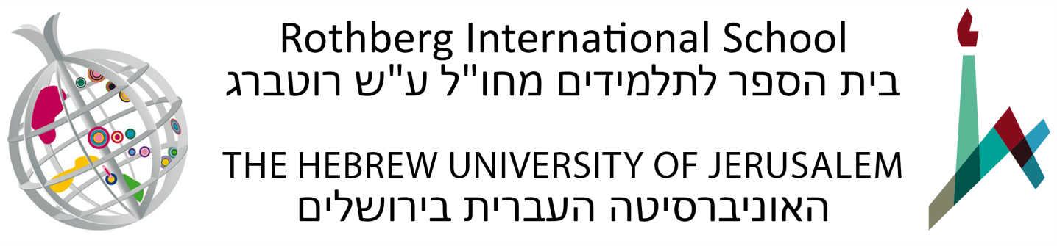

Arabic Immersion Program Elementary Level (48878)
Summer Semester: June 14 – July 26, 2022
Various days and times per week, Sunday through Thursday
150 Academic Hours, 10 Academic Credits
Office hours: Teachers will hold office hours to assist students.
Tentative Syllabus

Course Description
This program is intended as an introduction to Modern Standard Arabic (henceforth MSA), the formal language employed in books, newspapers, scripted news broadcasts and formal speeches across the Arab world. Students will also learn the foundations of Colloquial Arabic (henceforth CA), the spoken language used at home and in daily life. As the specifics of this language vary from one location to another, emphasis will be placed on the Urban Palestinian dialect of Jerusalem, which is one of the Levantine dialects.

The classes and activities will facilitate the acquisition of a basic proficiency in the language and the basic linguistic skills, analytical abilities and cultural knowledge required to read, write and speak Arabic at a basic level.

The program is based on the principle of immersion, the comprehensive and active use of the language of study, both inside and outside the classroom. Arabic will therefore be taught in Arabic, though certain subjects may be taught in English at the beginning of the program, with a gradual move to Arabic as the program progresses. Participants will reside with Arabic speakers in the Student Village and interact with the Arabic speaking community in various field trips and special activities.

Course Objectives
- To master the Arabic alphabet and be able to distinguish and pronounce all Arabic sounds.
- To read and comprehend a variety of basic texts in MSA.
- To compose sentences using a basic level of MSA.
- To begin to converse in CA about familiar topics.
- To understand the phonology, morphology, syntax and semantics of the Arabic language.
- To become familiar with Arabic culture and literature and to be able to respond in culturally appropriate ways to daily situations in Arab culture and society.

Course Requirements
- Students are required to participate in all components of the program and to attend all classes and activities.
- Students are required to complete all assignments and exams.
- Unless given written permission by the teacher, all assignments, papers and exams are to be prepared and submitted individually.
- Students must comply with the policies of the Hebrew University and the Rothberg International School.
- The course will serve as the core component of the Arabic Immersion Program which integrates all of the other elements. Classes will utilize the Al-Kitaab text book series, in addition to materials prepared by the teaching faculty. The course will include both MSA and CA. Students are expected to complete most of Part 1 (3rd edition of Al-Kitaab).

Class Attendance and Participation
Students are required to participate in all components of the program and to attend all classes and activities. Failure to attend classes will result in a student being denied the right to partake of the final assignment and receive a final grade in a course. Students who have a justified reason to miss class (illness, mourning, etc.) must communicate with their instructors and the Department of Summer Courses and Special Programs, and complete the material that they have missed. Students who have missed class due to illness must obtain a signed and stamped sick note from a treating physician and submit it to the Department of Summer Courses and Special Programs immediately following their return to class. Failure to do so will result in an unexcused absence. The Department reserves the right to refer the issue to an Academic Committee. In some cases, the Academic Committee may decide, in light of the requirements of the course, that it is not possible to make up the missing course work.

Final Grade Breakdown
- Active participation in class and current preparation of all assignments, weekly quiz and midterm exam – 40%
- Final exam – 60%

Course Outline
Core Course in Arabic
Classroom Instruction and Co-curricular Activities
(90 hours of MSA and 60 of CA)
- The class meets approximately 30 hours a week, divided between MSA (including grammar, syntax, reading, writing, etc.) and CA (including active usage, listening comprehension, grammar, syntax, etc.).
- The CA sessions also include Trips/Activities.

Course General Readings (Must be purchased before arrival)
- Kristen Brustad, Mahmoud Al-Batal and Abbas Al-Tonsi, Alif Baa: Introduction to Arabic Letters and Sounds, 3rd ed. (Washington, D.C.: Georgetown University Press, 2010) (includes DVD). Overseas Library 492.7 B912 (CD 017)

- Kristen Brustad, Mahmoud Al-Batal and Abbas Al-Tonsi, Al-Kitaab fii Ta^{c}allum al-^{c}Arabiyya: With DVDs – A Textbook for Beginning Arabic, Part 1, 3rd ed. (Washington, D.C.: Georgetown University Press, 2011). Overseas Library 492.7 B912

