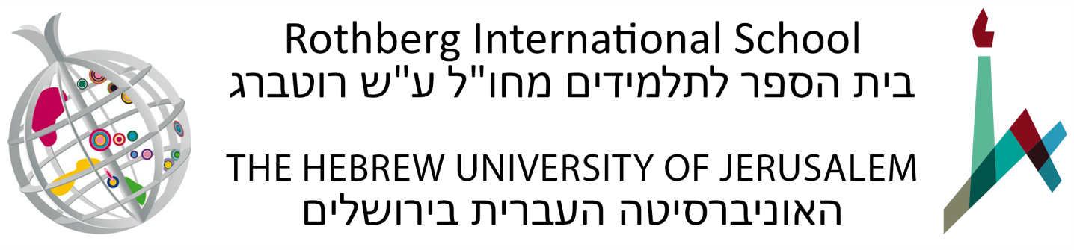

Arabic Immersion Program Advanced Level (48883)
Summer Semester: June 14 – July 26, 2022
150 Academic Hours, 10 Academic Credits
Office hours: Teachers will hold office hours to assist students.
Tentative Syllabus

Course Description
The course objective is to prepare students for independent studies in MSA with special emphasis on vocabulary enhancement and communicative skills. The course moves beyond the textbook by making use of additional texts to satisfy the needs of the students to have access to the real and current world of Arabic. The students will have the opportunity to read and discuss current issues in the Arab world, by dealing with topics such as political Islam and cultural traditions in literature. The course will use materials from newspapers and the internet to give the students the chance to engage actively in discussions. Special emphasis will be put on oral discussions, writing multi-paragraph essays on different topics, summarizing texts, and translation.

This program is intended as a continuation to students' studies in Modern Standard Arabic. In addition, students will learn more advanced skills in colloquial Arabic. As the specifics of this language vary from one location to another, emphasis will be placed on the Urban Palestinian dialect of Jerusalem, which is one of the Levantine dialects.

The classes and activities will facilitate the acquisition of language and linguistic skills, analytical abilities and cultural knowledge required to proficiently read, write and speak Arabic.

The program is based on the principle of immersion, the comprehensive and active use of the language of study, both inside and outside the classroom. Participants will interact with the Arabic speaking community in various extracurricular activities.

Classes will utilize the Al-Kitaab text book series, in addition to materials prepared by the teaching faculty. The course will include both Modern Standard Arabic and colloquial Arabic (Palestinian dialect).
Course Objectives
- To read and comprehend a variety of texts in Modern Standard Arabic.
- To compose paragraphs in Modern Standard Arabic.
- To converse in spoken Arabic about familiar topics.
- To understand the phonology, morphology, syntax and semantics of the Arabic language at an advanced-intermediate level.
- To become more familiar with Arabic culture and literature and to be able to respond in culturally appropriate ways to daily situations in Arab culture and society.

Course Requirements
- Students are required to participate in all components of the program and to attend all classes and activities.
- Students are required to complete all assignments and exams.
- Unless given written permission by the teacher, all assignments, papers and exams are to be prepared and submitted individually.
- Students must comply with the policies of the Hebrew University and the Rothberg International School.
- The course will serve as the core component of the Arabic Immersion Program which integrates all of the other elements. Classes will utilize the Al-Kitaab text book series, in addition to materials prepared by the teaching faculty. The course will include both MSA and CA (Levantine dialect). Students will begin studying from the middle of Al-Kitaab Part 1 (3rd edition) and are expected to complete the entire book by the course mid-point and to begin Al-Kitaab Part 2.

Class Attendance and Participation
Students are required to participate in all components of the program and to attend all classes and activities. Failure to attend classes will result in a student being denied the right to partake of the final assignment and receive a final grade in a course. Students who have a justified reason to miss class (illness, mourning, etc.) must communicate with their instructors and the Department of Summer Courses and Special Programs, and complete the material that they have missed. Students who have missed class due to illness must obtain a signed and stamped sick note from a treating physician and submit it to the Department of Summer Courses and Special Programs immediately following their return to class. Failure to do so will result in an unexcused absence. The Department reserves the right to refer the issue to an Academic Committee. In some cases, the Academic Committee may decide, in light of the requirements of the course, that it is not possible to make up the missing course work.
Final Grade Breakdown
- Active participation in class and current preparation of all assignments, weekly quiz, Midterm exam – 40%
- Final exam – 60%

Components of the Program
1) Core Course in Arabic/Classroom instruction (30 hours a week)
- 15 weekly hours will be devoted to written Arabic (grammar, syntax, reading, writing, etc.). Part of these hours will be focused on reading contemporary texts in Arabic (newspapers, internet and magazines) that will help students become more familiar with both Arabic language and generate class discussions and reflective writing on local social and cultural issues.
- 10 weekly hours will be devoted to colloquial Arabic (active usage, listening comprehension, grammar, syntax, etc.), including language lessons in the field.

2) Co-curricular Activities
- Field Trips to Jerusalem and its surroundings, Northern Israel and elsewhere
- Social Activities such as movies, coffee hours, etc.

Required Books (students must purchase these before arrival)

Kristen Brustad, Mahmoud Al-Batal and Abbas Al-Tonsi, Al-Kitaab fii Ta^{c}allum al-^{c}Arabiyya: With DVDs – A Textbook for Intermediate Arabic, Part 2, 3rd ed. (Washington, D.C.: Georgetown University Press, 2011). Overseas Library 492.7 B912

Hans Wehr, Arabic-English Dictionary: The Hans Wehr Dictionary of Modern Written Arabic, 4th ed. (Urbana, Ill.: 1994 and various printings). Overseas Reference (Dic. A:E W414)

